Purpose – sell cheese to people across the EU who want to buy authentic cheese.

Target – People who enjoy cheese culture. We prioritise selling to cheese lovers, and the brand should reflect quality cheese to make it usable for people with lesser cheese knowledge to buy cheese as a present for others.

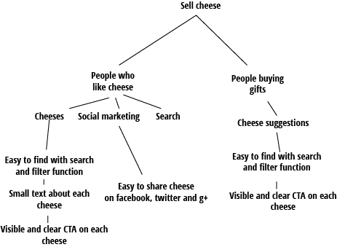

**User stories**

|  |
| --- |
| **Function**: Customer wants to buy cheese online |
| To be able to buy from a large selection of cheeses |
| And have them sent and delivered to a home address |
|  |
| **Scenario:** |
| If I enter a cheese in search field |
| And one or more cheeses are returned from database |
| And I’ve added a cheese to shopping chart |
| Then I’ll be able to proceed to shopping chart |

|  |
| --- |
| **Function**: Customer wants to buy a gift |
| Without much knowledge of cheese |
| And have them sent and delivered to a home address |
|  |
| **Scenario:** |
| If I enter the site without cheese knowledge |
| I’ll be able to filter these cheese according to country |
| Or according to type of cheese |
| And I’ll be able to add a cheese to shopping chart |

**Importance of content**

|  |  |  |  |
| --- | --- | --- | --- |
| **Content** | **type** | **section** | **priority** |
| Logo and brand | branding | SW | 3 |
| Search field | navigation | SW | 4 |
| About us | branding | Main | 2 |
| Browse select cheeses | information | Main | 2 |
| Navigation menu | navigation | SW | 3 |
| Contact | service | SW | 1 |
| Cheese origin | informative | Main and product | 2 |
| Cheese CTA | CTA | SW | 4 |